Core& Contracts - Guidelines
Version: 1 December 2019

THE BASICS
The Core& Contracts are contract templates available for the procurement of ICT/digital solutions that are low risk and involve expenditure of up to $500,000 (excluding GST). As part of the Procure IT framework, the use of the Core& Contracts is mandated by Procurement Board Direction 2018-02.
They are called Core& because they’re built around Core Terms which contain NSW Government’s minimum legal terms.
The Core& Contracts consist of 2 easy-to-use versions dependent on your procurement needs; Core& One and Core& Combined.

Core& One

Core& One has been designed so you can use it when procuring one individual solution in one transaction; for instance, if you’re only procuring As-a-Service, then Core& One is the contract for you. Core& One is made up of the Core& One - Core Terms plus a set of 4 separate individual Core& One - Solution Requirements that you can choose from.

The Core& One - Core Terms then combine with the relevant Core & One - Solution Requirements to create the Core& One contract.

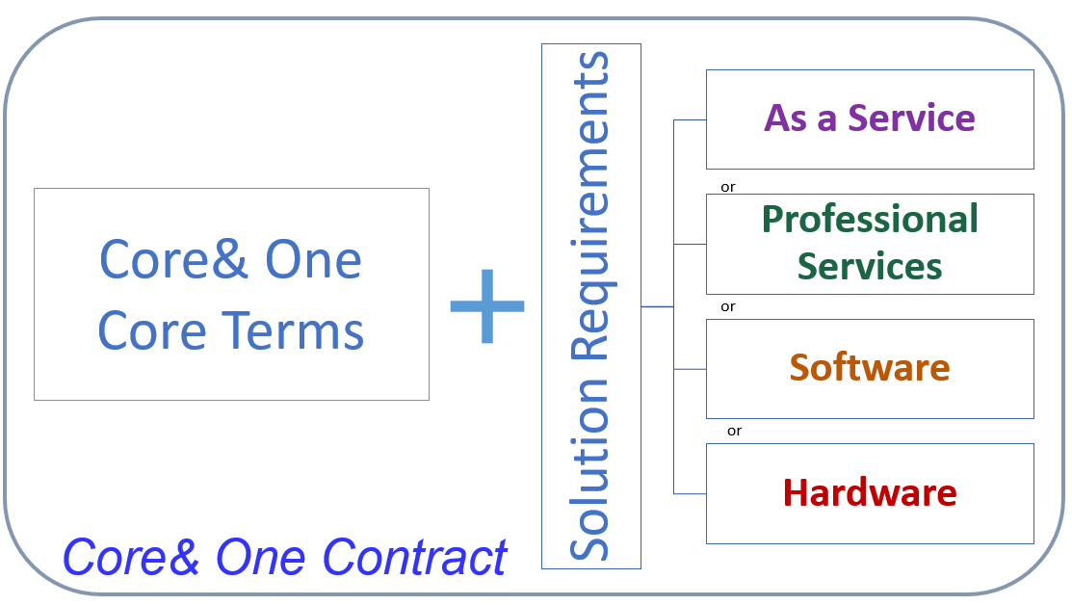

Core& Combined

Core& Combined has been designed to be used when you are procuring more than one solution in one transaction; for instance, if you’re procuring both As-a-Service and Professional Services under one transaction then, Core& Combined is the contract for you. Core& Combined is made up of the Core& Combined - Core Terms plus Part A: Combined Common Terms & Part B Combined Solution Requirements which have been consolidated into one document for ease of reference.

The Core Terms (Combined Version) together with Part A: Combined Common Terms and the relevant Solution Requirements that you have selected in Part B integrate to create the Core& Combined contract.
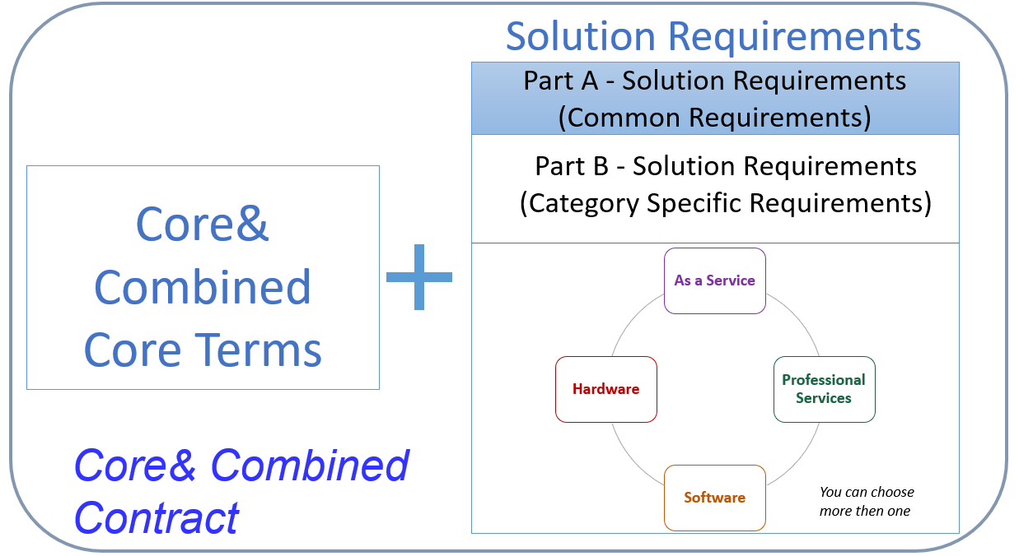

WHEN TO USE THE CORE& CONTRACTS
The Core& Contracts are for low risk procurements where the contract value is up to $500,000 (excluding GST). All agencies have the onus of conducting a risk assessment for each procurement.
By way of guidance, the Core& Contracts are not suitable for procuring ICT solutions which:
  - are critical inputs to other projects with a higher risk profile
  - could severely or critically affect an agency's functions or service delivery
  - involve “Personal Information” being stored or transferred off-shore, or being accessed remotely from offshore by persons who are not authorised
  - involve the performance of services or access to classified environments which require security or police clearances
  - involve multiple specialists from different vendors, increasing risks around coordination and the provision of deliverables within a budget
  - could attract publicity or media attention, increasing the likelihood of additional probity or risk management requirements or political scrutiny
For further guidance, please refer to our current Risk Assessment Toolkit available in the ICT Services Scheme. Please note: this toolkit is not designed to replace a comprehensive risk assessment and do not override Agency policies on risk management or procurement (contracting) requirements.

HOW TO USE THE CORE& CONTRACTS - STEP BY STEP
Follow these steps when creating a Core& contract
Step 1: Assess risk and estimate the contract value
- Is the procurement low risk?
- Does the total contract value fall within the $500,000 threshold (excluding GST)?
If yes: continue to Step 2.
If no: if your procurement falls outside these parameters, please continue to use the most appropriate agreement type. Most likely this will be Procure IT 3.2.
For the purposes of calculating the contract value, this value:
  - Should not be split into lower-price components and
  - Must be the estimated total price over the term of the contract including any optional extension periods and not a price per annum.
For more information, please refer to our ICT/Digital Sourcing Handbook for Buyers.
Step 2: Using the right Core& Contract for your procurement
- Are you procuring only one individual solution? i.e. only procuring Software.
If yes, please continue to the Procuring One Individual Solution section.
If no i.e. you are procuring more than one solution, please refer to Procuring More than One Solution
Step 3.
Procuring One Individual Solution
- Use the correct version of the Core& One - Core Terms available here.
- Choose one of the Core& One - Solution Requirements template that matches your procurement needs from the following options:
  - Professional services: this template is for services performed by personnel, based on the buyer’s requirements. It is available for both ICT and non-ICT professional services
NB: Professional services do not include resources provided under the direction, control and supervision of the Customer – this type of external labour is covered by the Contingent Workforce Prequalification Scheme.
  - As-a-service: this template is for services delivered ‘off premises’ from outside the buyer’s environment via a service stack (including software/hardware components). Characteristics of as-a-service commonly include:
- services are shared, delivered to multiple clients
- pricing is subscription or consumption-based
- solution requirements are focused on service performance and outcomes, rather than how the supplier manages back-end service delivery
  - Software: this template is for licensing software that is hosted in the buyer’s environment, with options for software maintenance and support
  - Hardware: this template is for the supply of ICT hardware
- Complete and sign the chosen Core& One - Solution Requirements template.
- Each Core& One - Solution Requirements template you fill out and sign creates a separate Core& One incorporating the Core& One - Core Terms.
- The Core& One - Core Terms govern performance of that Core& One contract including how the solution described in the solution requirements will be supplied. They take priority over these solution requirements.
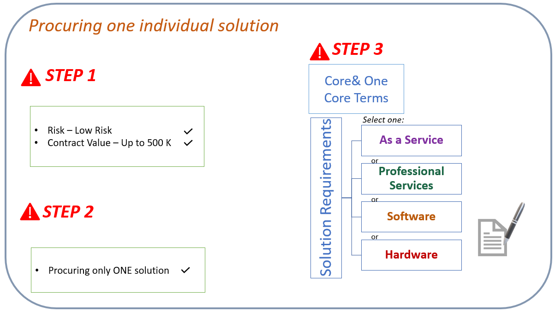
Procuring More than One Solution
      - Use the correct version of the Core& Combined - Core Terms available here.
      - Use the Part A: Combined Common Terms & Part B Combined Solution Requirements available here.
        - Part A contains all those common requirements which apply to all solutions you want to procure; so, complete all the relevant information in Part A;
        - Part B contains the solutions requirements for Professional services; As-a-service; Software and Hardware all consolidated into one document; so, select and complete the relevant information which relate to each specific category for your procurement. The selected categories for this Agreement are identified on the Signing Page.
        - Sign the Signing Page on Part A
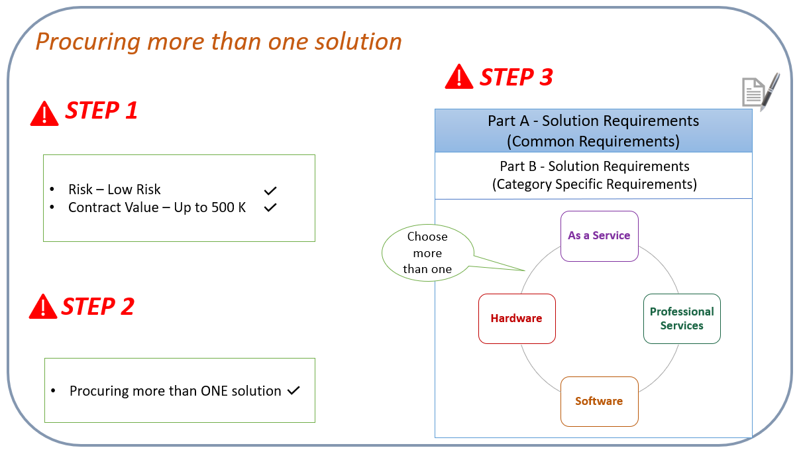
Note: If you are a NSW Government Agency procuring As-a-Service using Core& Combined, and decide to terminate the agreement for convenience, there is a risk that any pre-paid amounts will be forfeited. As such, it is recommended that you assess the appropriate method of payment earlier on; for instance i.e. quarterly payments might help you to minimise risk.

Are the Core& Contracts mandatory?
Summary of implementation dates
The Core& Contracts form part of the Procure IT framework. NSW Government agencies must use the Procure IT Framework to buy information and communications technology (ICT) related goods and services. Refer to: Procurement Board Direction 2018-02.
The Core& Contracts are mandatory for low risk ICT procurement involving expenditure of up to $500,000:

Can I vary any of the terms?
Government agencies are not permitted to vary the Core& Contracts without the written approval of the Department of Customer Service (DCS), except in the case of beneficial variations as specified below or where there is an option to choose from in the relevant Solution Requirements. This is as per Procurement Board Direction 2018-02. The Department will approve variations that are reasonable and necessary to accommodate unique features of a particular procurement.

Beneficial variations: Government agencies are not required to seek DCS approval for beneficial variations which clearly improve the customer’s contractual position. For example, amendments improving or adding to the customer’s legal rights and amendments imposing additional obligations on the Contractor.
However, government agencies must provide prior written notification of such variations to DCS Legal, supported by legal advice confirming the variations are beneficial in nature.

Am I able to provide feedback?

We’d love to hear from you
If you have any comments or questions about the Core& Contracts, or would like to receive updates about the development of the new procurement contracting framework, please email us at ICTServices@customerservice.nsw.gov.au

